**DEPARTMENT OF HIGHER NATIONAL DIPLOMA IN INFORMATION TECHNOLOGY**

**SRI LANKA INSTITUTE OF ADVANCED TECHNOLOGICAL EDUCATION**

**(SLIATE)**

INDIVIDUAL PROJECT INTERIM REPORT

**IOT BASED AUTOMATIC BELL SYSTEM WITH MOBILE APPLICATION**

SUPERVISED BY

Mr. P. PIRAPURAJ

SITHAMPARAPILLAI KATHEESKUMAR

(DEVELOPER TRACK)

BAT/IT/2018/FT/030

**Table of Contents**

**TABLE OF FIGURES** 1

**1.** **INTRODUCTION** 2

**2.** **BACKGROUND AND MOTIVATION** 2

**3.** **OBJECTIVES** 3

**4.** **SYSTEM ANALYSIS** 3

**4.1.** **FACT FINDING TECHNIQUES** 3

**4.2.** **SOFTWARE REQUIREMENT SPECIFICATION** 4

**4.2.1.** **PRODUCT DESCRIPTION** 4

**4.2.2.** **SYSTEM REQUIREMENTS** 4

**4.2.2.1.** **NON FUNCTIONAL REQUIREMENTS** 4

**4.2.3.** **FUNCTIONAL REQUIREMENTS** 5

**4.2.4.** **SOFTWARE AND HARDWARE REQUIREMENTS** 5

**4.3.** **PROGRAMMING LANGUAGES & LIBRARIES** 6

**5.** **SYSTEM DESIGN** 7

**5.1.** **ER DIAGRAM** 7

**5.2.** **DFD DIAGRAM** 8

**5.3.** **USE CASE DIAGRAM** 9

**5.4.** **ANDROID APP UI DESIGN** 10

**6.** **REFERENCES** 14

# **TABLE OF FIGURES**

Figure 1 ER Diagram 7

Figure 2 DFD Diagram 8

Figure 3 Use case Diagram 9

Figure 4 Mobile App Login UI 10

Figure 5 Mobile App Bell Ringing time set UI 11

Figure 6 Mobile App System Setting UI 12

Figure 7 Mobile App User profile UI 13

# **INTRODUCTION**

The ringing of a school bell is a signal that tells a school's students when it is time to go to class in the morning or afternoon and when it is time to change classes during the day as well as when students are dismissed from school. Typically the first bell tells the students that it is time to report to class, and the bell that occurs shortly after that means that the students are late. There may also be a warning bell between the first bell and the late bell.

In some schools it may take the form of a physical [bell](https://en.wikipedia.org/wiki/Bell_(instrument)), usually electrically operated. In other schools it may be a tone, siren, electronic bell sound, a series of chimes, or music played over an [intercom](https://en.wikipedia.org/wiki/Intercom_system_(school)).

School bell device or system of alarm devices gives an audible, visual or other form of a signal about a condition. Bell devices include alarm clocks, distributed control systems, bells in an operation and maintenance monitoring system etc. In most schools and colleges across the world, especially in Sri Lanka, bells act as alarm devices, which are rung in accordance to the daily schedule implemented by the school authorities. The bells, in most cases, are rung manually, to indicate the start or end of periods, with the help of a person. While this helps to get the job done, but it also raises several questions. Firstly, the looming questions of accuracy remain persistent. For the purposes of maintaining the daily schedule and maintaining the bell, an individual needs to be tasked with the job, which raises the question of necessity of manpower and the increased costs, as per of his monthly wages, that comes with it.

The design of an easily configurable bell system will help to eliminate all of the above shortcomings. While such designs are currently available today, a Mobile application has been added in the system to eliminate the hassle faced by users. The bell system can be set and configured with the greatest of use through the application of a user friendly and simple interface. The system is also economically and technologically feasible, making it an affordable and long-term substitute.

The project is being developed on the open sourced Arduino Platform. The Internet of Things (IoT) function is being enabled by an Arduino. The hardware circuit provide Wi-Fi signal to communicate mobile devices and detects the supported host to set bell ringing times via mobile phone.

# **BACKGROUND AND MOTIVATION**

SKH Bell is a smart, affordable device that helps you manage school bells via smartphone. It also saves your time, effort, and maintains excellent accurate timing and provides security as well. You’ll receive notifications when bells are added to your school physical electric bell, and you’ll be able to keep track of your school bell. In order to improve the belling system of BT/Kannankudah Maha Vidyalaya, the implementation phase is highly expected to fulfill the need of the school in a successful manner.

# **OBJECTIVES**

The real-time bell system is an effective and efficient method whereby immediate new time changing and disable bells will be delivered via notification. we defined the following objectives in order to fulfill the need of the intended users.

* To create a fully automated and user-friendly bell systems that can be operated through PCs or via smartphones at schools
* To maintain an effective time management through the punctual bell system
* To access every function of the bell system through smartphone effectively

# **SYSTEM ANALYSIS**

In this chapter, I will discuss and analyze about the developing process of Learning Management System including software requirement specification (SRS) and comparison between existing and proposed system. The functional and nonfunctional requirements are included in SRS part to provide complete description and overview of system requirement before the developing process is carried out. Besides that, existing vs. proposed provides a view of how the proposed system will be more efficient than the existing one.

## **FACT FINDING TECHNIQUES**

Fact-finding techniques are used to gathering requirements from the users. For this part, I used various fact-finding techniques such as questionnaires, interviews in their school and sampling, etc.

Mostly I used interview type and observation type for fact findings which are simplified our tasks on gathering information on this project. I interviewed Principle of BT/Kannankudah Maha Vidyalaya and some teachers who work under the BT/Kannankudah Maha Vidyalaya. I prepared some questions, choose the time and place then interviews the person who related to this system and gather the requirement fact. They gave us accurate information data for our project.

## **SOFTWARE REQUIREMENT SPECIFICATION**

### **PRODUCT DESCRIPTION**

Automatic Bell System is an IoT based system which helps user (principle / Teachers) to manage the subject divided activity in electronic format. It reduces the risk of human work.

It can help user to manage the bells more effectively and timesaving.

### **SYSTEM REQUIREMENTS**

### **NON FUNCTIONAL REQUIREMENTS**

* Efficiency Requirement
  + When an Automatic bell system will be implemented Admin will easily access school bells via mobile phone will be very faster.
* Reliability Requirement
  + The system should accurately perform and every moment displayed time on build in screen
* Usability Requirement
  + The system is designed for a user friendly environment so that teachers of School can perform the taks an effective way.
* Implementation Requirements
  + In implementing whole system it uses XML in front end with JAVA as language which will be used for API connectivity and the backend.
* Delivery Requirements
  + The whole system is expected to be delivered in six months of time with a weekly evaluation by the project guide.

### **FUNCTIONAL REQUIREMENTS**

* User Login
  + This feature used by the user to login into system. They are required to enter user id and password before they are allowed to enter the system .The user id and password will be verified and if invalid id is there user is allowed to not enter the system.
* Add New Times / Update time
  + Setup the bell ringing times
* Update the system setting
  + Can change bell ringing duration
  + Can enable or disable ringing on Saturday
  + Can enable or disable today off bells
* User Profile management
  + Update user login email
  + Update password

### **SOFTWARE AND HARDWARE REQUIREMENTS**

This section describes the software and hardware requirements of the system

#### **SOFTWARE REQUIREMENTS**

* Operating System
  + Linux (Debian-based distributions)
  + Windows Operating System
* Application Software
* ARDUINO development IDE
* Android Studio IDE
* Postman
* Documentation :Microsoft Word 2013

#### **HARDWARE REQUIREMENTS**

* IoT Hardware
* NodeMCU 12E Board
* RTC3231 Module (Real Time Clock)
* Relay Module (High voltage Switch)
* OLED Display
* Power Supply (HLK-PM01)
* Custom PCB
* LED’s, Resisters, Diodes, BC547 Transistor
* Computer Hardware
* Intel core Pentium Processor
* 4GB Ram

## **PROGRAMMING LANGUAGES & LIBRARIES**

* Mobile application developed by JAVA
* IOT programming by C++
* IOT Libraries
  + RtcDS3231.h
  + ESP8266WiFi.h
  + ESP8266WebServer.h
  + ESP8266HTTPClient.h
  + Adafruit_GFX.h

# **SYSTEM DESIGN**

## **ER DIAGRAM**

|  |
| --- |
|  |
|  | Figure 1 ER Diagram |
|  |  |
|  |  |
|  |  |
|  |  |
|  |  |
|  |  |
|  |  |
|  |  |
|  |  |

## **DFD DIAGRAM**

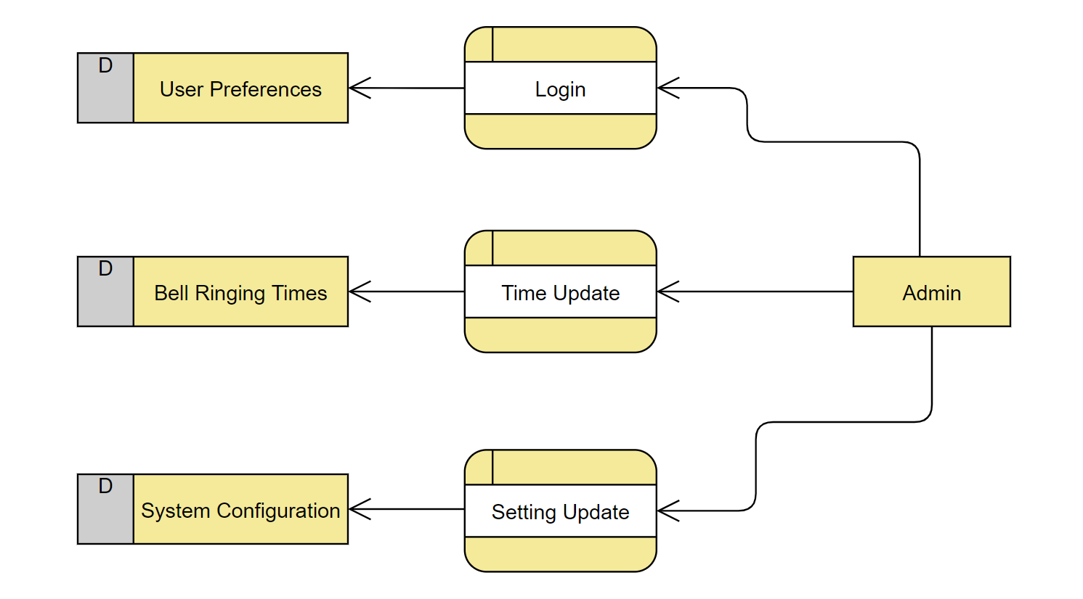

Figure 2 DFD Diagram

## **USE CASE DIAGRAM**

Figure 3 Use case Diagram

## **ANDROID APP UI DESIGN**

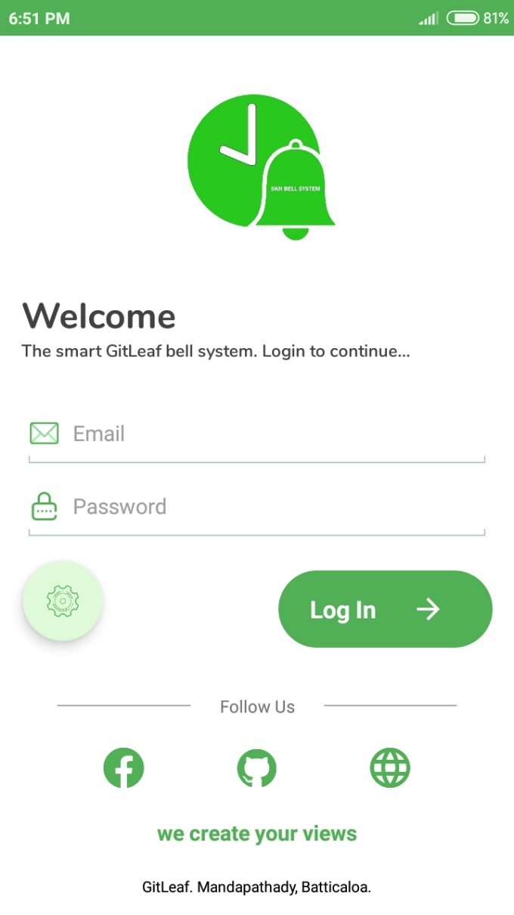

Figure 4 Mobile App Login UI

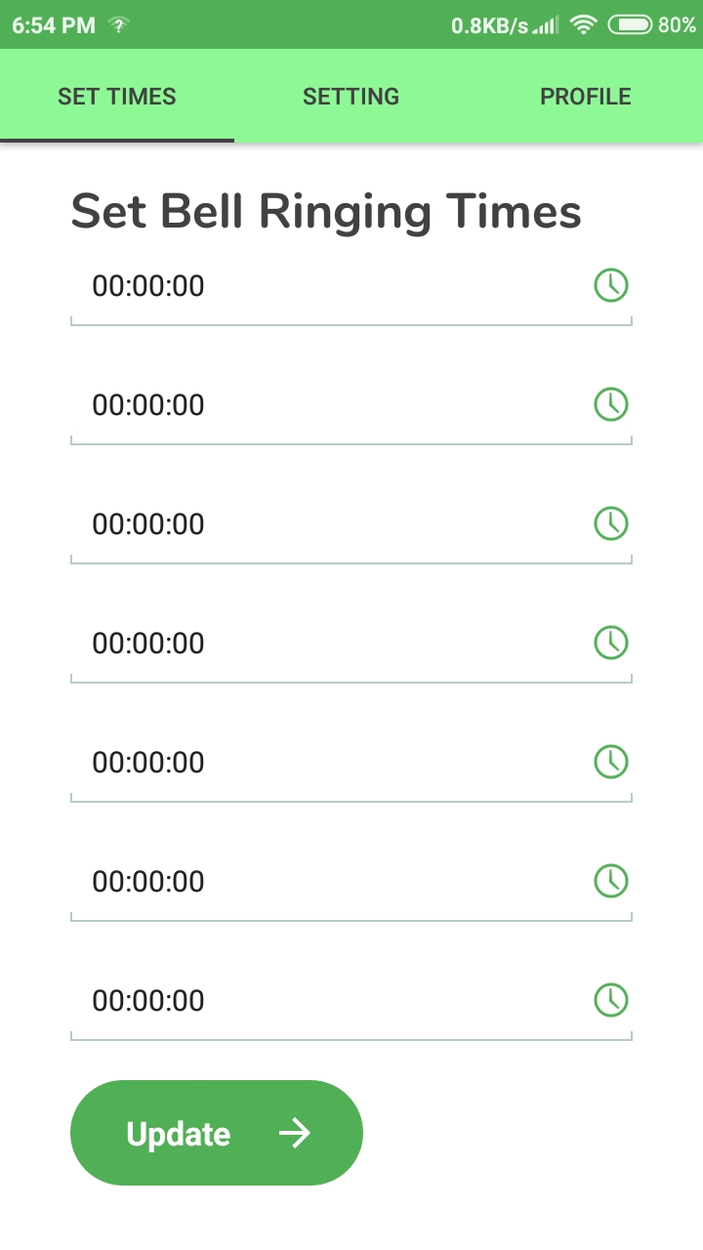

Figure 5 Mobile App Bell Ringing time set UI

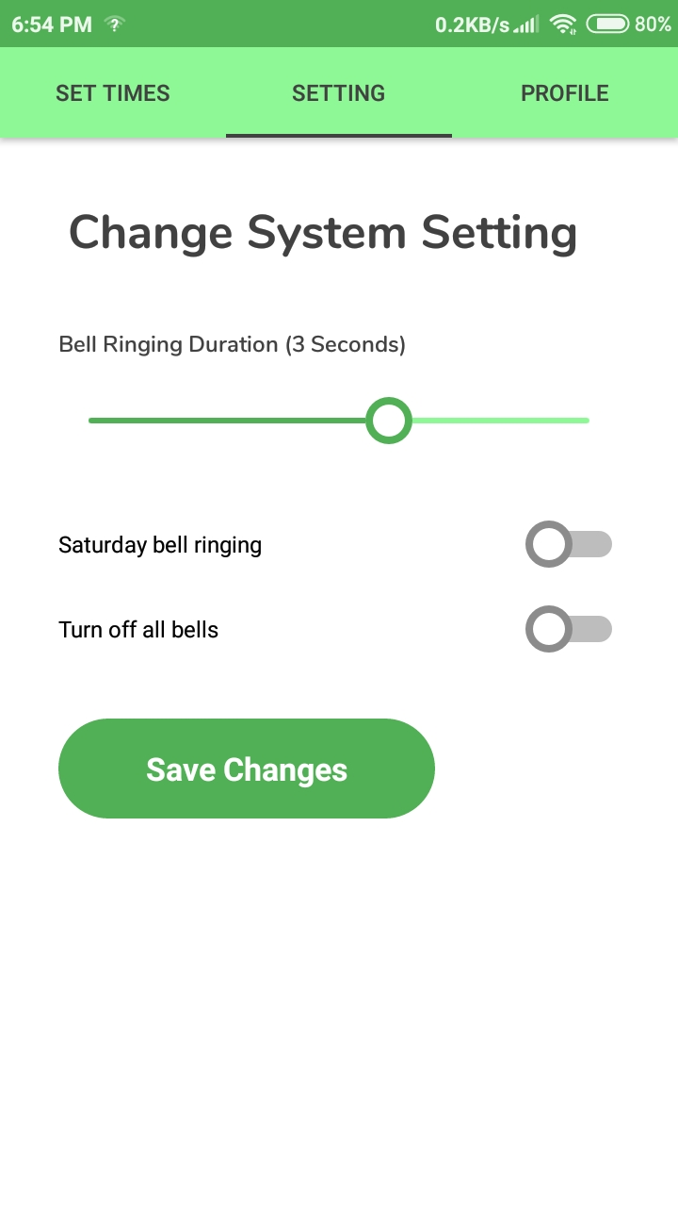

Figure 6 Mobile App System Setting UI

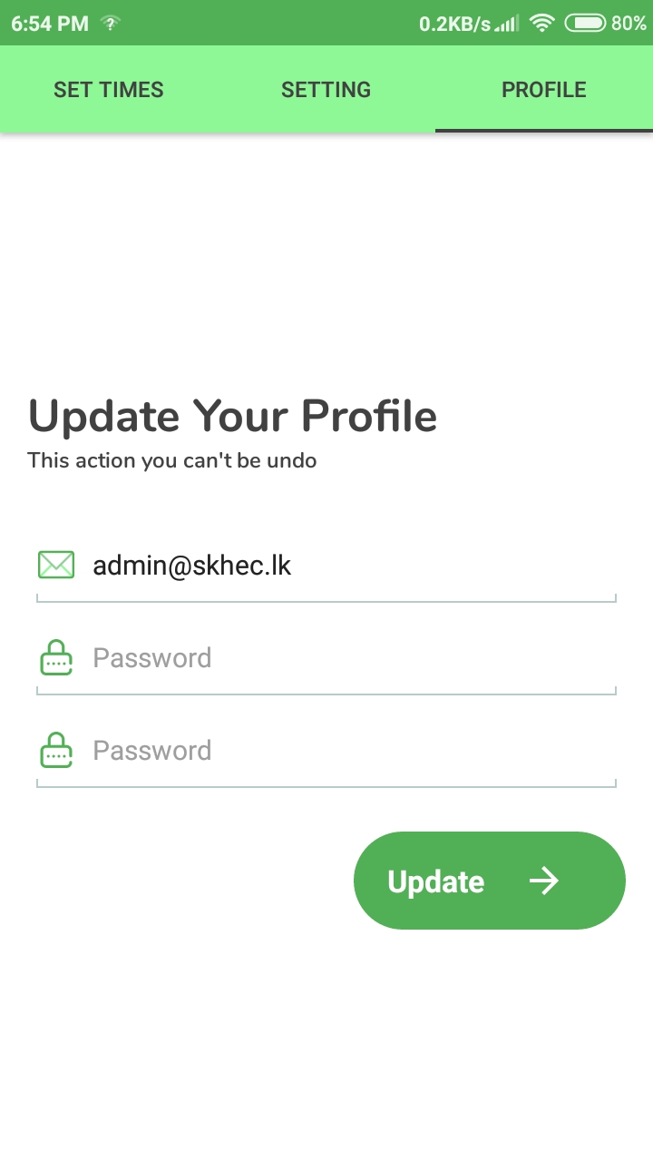

Figure 7 Mobile App User profile UI

# **REFERENCES**

“*Arduino* Developers,” *Arduino*. [Online]. Available: https://www.arduino.cc/. [Accessed: 20-Feb-2020].

“Android Developers,” *Android Developers*. [Online]. Available: https://developer.android.com/. [Accessed: 20-Feb-2020].

“An open-source firmware based on ESP8266 wifi-soc.,” *NodeMcu*. [Online]. Available: https://www.nodemcu.com/index_en.html. [Accessed: 20-Feb-2020].

“The Collaboration Platform for API Development,” *Postman*. [Online]. Available: https://www.postman.com/. [Accessed: 20-Feb-2020].

“Real time clock using NodeMCU, DS3231 and SSD1306 OLED,” *Simple Projects*, 27-Aug-2018. [Online]. Available: https://simple-circuit.com/nodemcu-ds3231-ssd1306-rtc/. [Accessed: 20-Feb-2020].